**Making Online Payments on a Desktop**

**in the TeacherEase Program**

1. Log into the program and click the fees button.

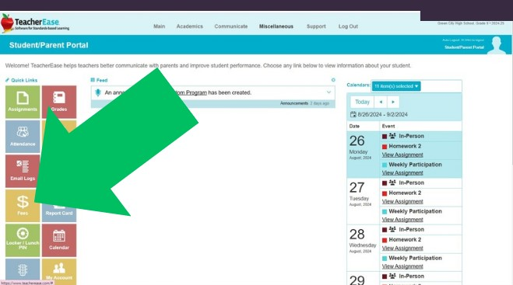

1. To see what fees are due, you can toggle from the lunch to Registration/Fees.
2. Click Make an online Payment

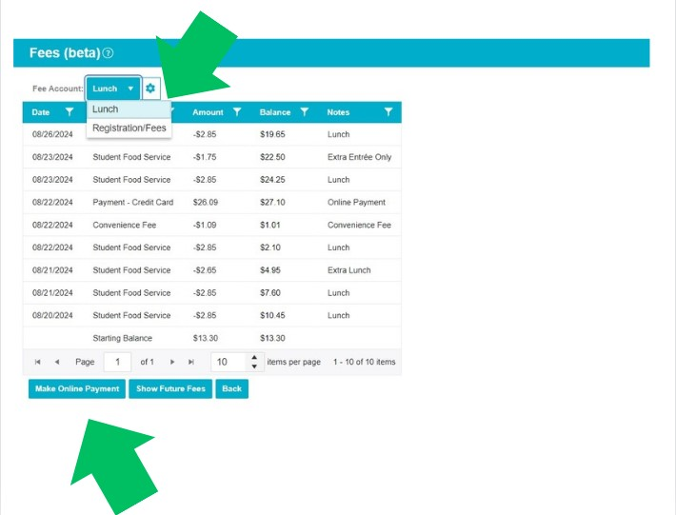

1. If you have a **positive lunch/breakfast balance** then you will want to type in the amount of money you would like to deposit. If you have a negative lunch balance, it will auto-populate to the amount needed to bring the account to $0. **You can edit this amount as well and type in the amount you want to pay.**
2. If you do not want to pay the entire balance for registration/fees, then choose the edit button and enter in the amount you would like to pay for each item listed.
3. The amount to be charged including the convenience fee charged by the company can be found near the bottom of the page.
4. Be sure to click the “I agree” statement
5. Click on checkout.

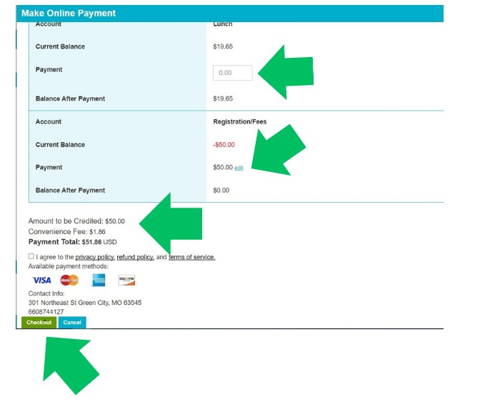

1. Enter your credit card information and billing address.

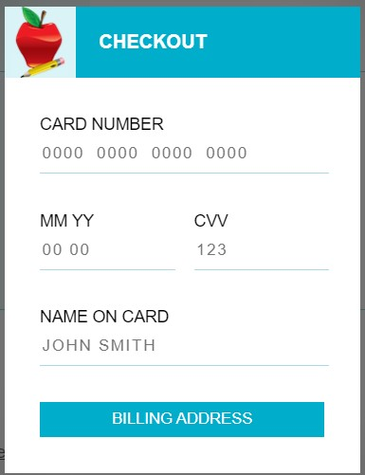

**Making Online Payments From the**

**TeacherEase App**

1. Log in to the app and click the MORE button at the bottom of the page.
2. Scroll down to the FEES/LUNCH BALANCE and click the gray button.

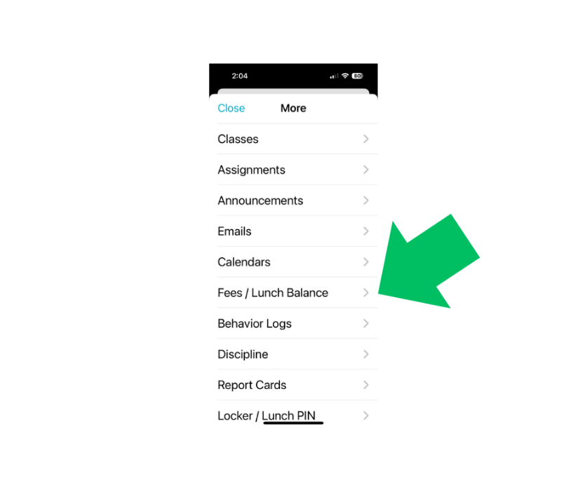

1. You will have the opportunity to pay for lunch fees and/or registration fees such as class dues, club dues, etc. Click on MAKE AN ONLINE PAYMENT.

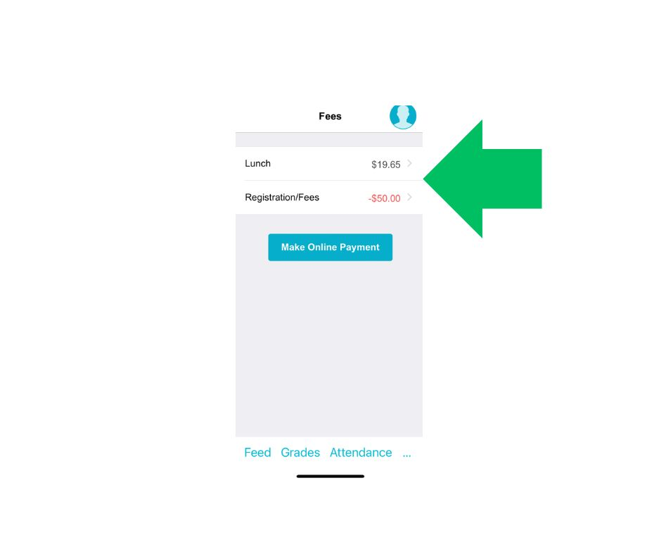

1. To change the amount you would like to pay, click on the EDIT button.

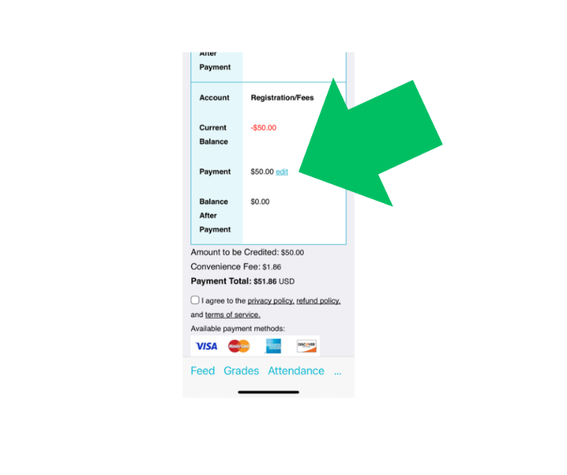

1. You can manually enter any of the amounts you would like to pay (or not pay.) For example, it may show that you owe class dues for 1st and 2nd semester and you may choose to only pay 1st semester. You would then enter $0.00 in the area for 2nd semester.

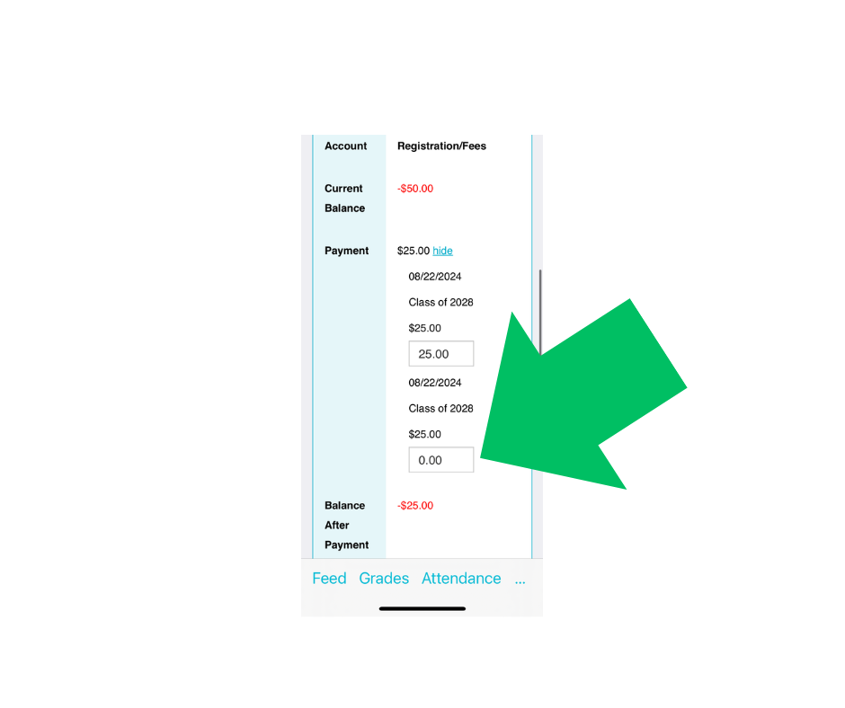

1. The total amount you are scheduled to pay can be found at the bottom of the screen and will also show the convenience fee that is required when paying by card. You will then click agreeing to the terms and conditions and then are able to CHECKOUT.

